**Linux RedHat**

**RH124**

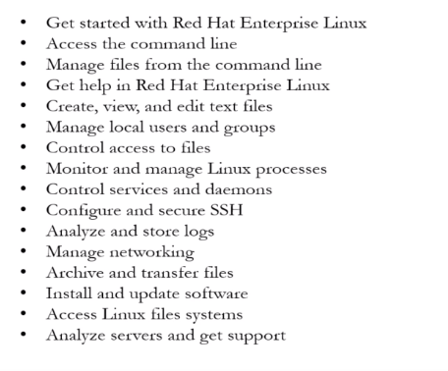

RH134

